Figuring out the rules for electron arrangement

This is one way the electron arrangement of the elements is drawn.
Element | Diagram of element | Electrons and group
Lithium |  | A black dot represents the nucleus. Lithium atoms have three electrons. A small circle around the nucleus has two red dots on, representing the first shell with two electrons. A larger outer circle has one red dot on, representing the second shell with one electron.  Lithium is in Group 1 of the Periodic Table.
Fluorine |  | Fluorine atoms have nine electrons.  Fluorine is in Group 7 of the Periodic Table.
Neon |  | Neon atoms have ten electrons.  Because its outer shell is full, neon is stable and unreactive.  Neon is in Group 8 (ie, the eighth group) of the Periodic Table.
Sodium | 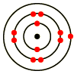 | Sodium atoms have 11 electrons.  Sodium is in Group 1 of the Periodic Table.
Calcium | 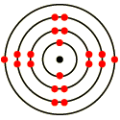 | Calcium atoms have 20 electrons.  Calcium is in Group 2 of the Periodic Table.

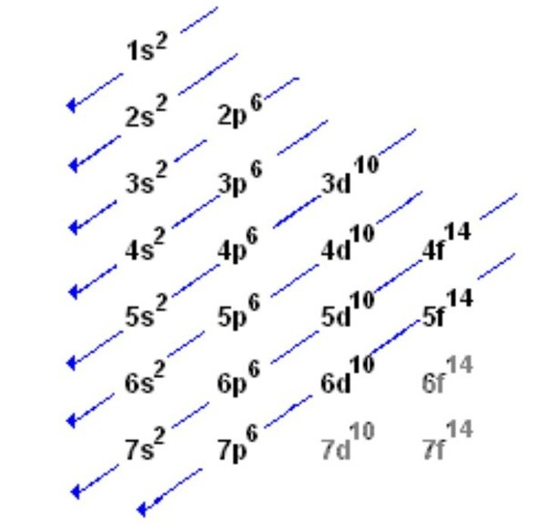
This is another way of showing how electrons are arranged in atoms

This is a third way of showing how electrons are arranged in atoms

QUESTION:
What does this information tell you about the rules for arranging electrons in atoms? Hint – there are 3 rules.

